
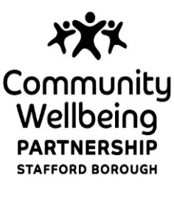

 | contact  direct dial  email  date | K Davies or PC Fatima  01785 619309 - Kirsty  ASBEnquiries@staffordbc.gov.uk or

Dear Parent/Guardian/Carer
Re: Anti-Social Behaviour-Stafford
It has been bought to our attention that during the Easter holiday period, a large number of school aged children have been identified as engaging in Anti-Social behaviour in Stafford Town Centre and surrounding areas. These behaviours are unreasonable and are resulting in harassment, alarm and distress being caused to other members of our local community by making them feel worried and scared. We are working with multi agency partners to identify the children involved.
In order to help us to address the offending behaviour and to prevent further incidents, we are asking for your support by talking to your children about this type of behaviour and by explaining that this is not acceptable.
Unfortunately, should this behaviour continue, enforcement actions may be considered in accordance with the Anti-Social Behaviour, Crime and Policing Act 2014.
Your support is much appreciated,
Yours Sincerely
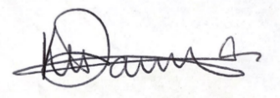
Kirsty Davies
Partnership Officer
On behalf of Stafford Community Wellbeing Partnership

