

School Uniform Policy

Date of Approval | October 2024 | Next Review Date | When change occurs
Approved by | Chair of Governors | Signed | 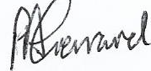

At Walton Priory Middle School, we expect a high standard of personal appearance by all pupils.
We are proud of our smart uniform and feel that it brings us together as a community and shares our school identity.

Our school uniform:
- Walton Priory blazer with yellow braiding and school logo
- White shirt
- Walton Priory tie with school logo
- Black, knee length skirt or tailored trousers
- Black or grey socks or tights
- All black school shoes (no yellow/white or other coloured stitching)
- Yellow gingham summer dresses (KS2) may be worn between Easter and October half term
- Black, knee length tailored shorts may be worn between Easter and October half term

Our school PE kit:
- School branded black t-shirt and/or black long sleeved games top.
- Black PE shorts (not gymnastic shorts eg, Nike Pro – 3 inch short or hot pants)
- Black tracksuit bottoms/sports leggings or the new branded tracksuit trousers
- White sport socks and black football socks (see PE information)
- Trainers
- Football boots
- Shin pads
- Mouth guard/gum shield
- Hair fastenings
No jewellery is to be worn for PE/Competitive sports including piercings.

ALL ITEMS OF UNIFORM AND PE KIT MUST BE FULLY NAMED

PE Kit information
Lesson | Full Kit Requirements
Gymnastics and Dance | Black round neck branded t shirt  Black shorts
Problem Solving | Black round neck branded t shirt  Black rugby shirt or quarter zip branded top  Black shorts/black tracksuit bottoms/sports leggings  Long black socks  Trainers
Football and Rugby | Black round neck branded t shirt  Black rugby shirt or quarter zip branded top  Black shorts/black tracksuit bottoms/sports leggings  Long black socks  shin pads  Football boot.  Gum shield for rugby - all years
Netball and Basketball | Black round neck branded t shirt  Black rugby shirt or quarter zip branded top  Black shorts/black tracksuit bottoms/sports leggings  Long black socks  Trainers
Hockey | Black round neck branded t shirt  Black rugby shirt or quarter zip branded top  Black shorts/black tracksuit bottoms/sports leggings  Long black socks  Trainers  Shin pads  Gum shield for all years
Health and Fitness (Boxing)  Athletics  Net and Wall  Quadgeball  Benchball  Cricket  Rounders  Handball  Multi-Sport Golf  Archery  Volleyball  Basketball  Tchoukball  Curling  Petanque | Black round neck branded t shirt  Black rugby shirt or quarter zip branded top  Black shorts  White socks  Trainers

No hoodies are allowed to be worn in PE or Games lessons due to the health and safety risk.

Uniform notes
- The blazer needs to be the branded school blazer with braiding and logo, available from our stockists
- Shirts must be white and have a collar and top button that is properly fastened
- The tie must be our black school tie with logo, available from stockists
- All skirts must be black and knee length. Long ‘maxi’ skirts, ‘tight tube’ skirts and ‘skater style’ skirts are not permitted. We are aware that many girls do wear skirts of inappropriate length and need your support to ensure that skirts are a suitable length
- All trousers must be black, of an appropriate tailored style and not tight fitting or skinny fit. Jeans, jeggings and combat style trousers are also not permitted

Skirts
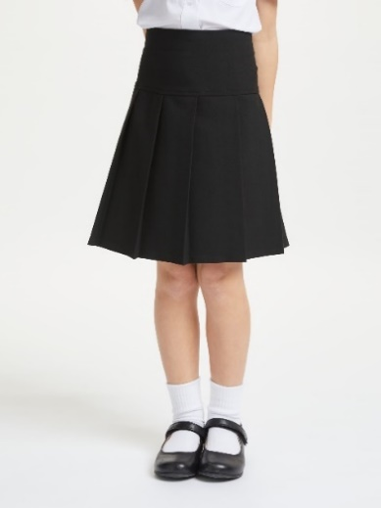

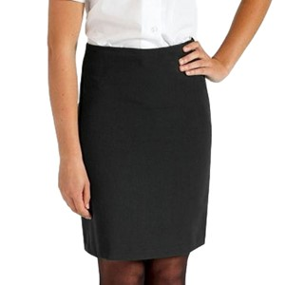
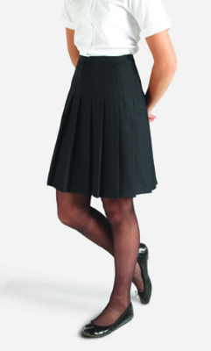
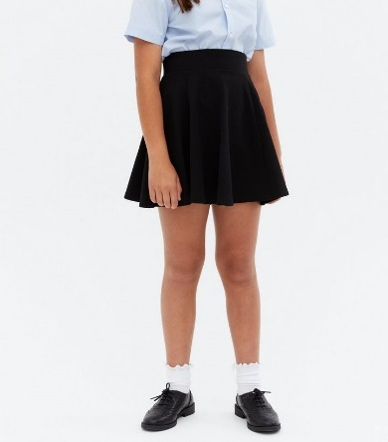

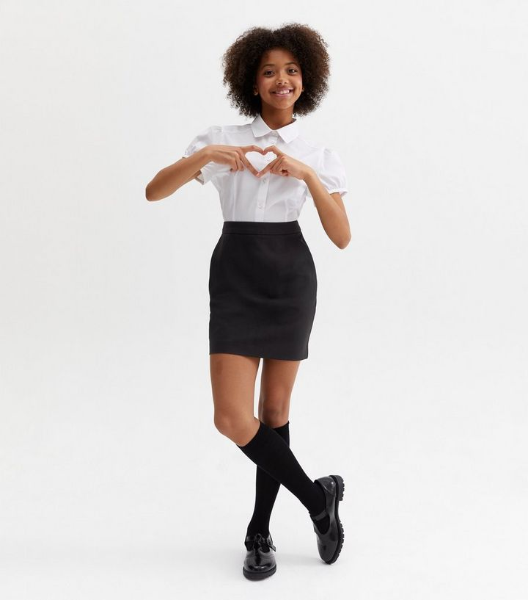
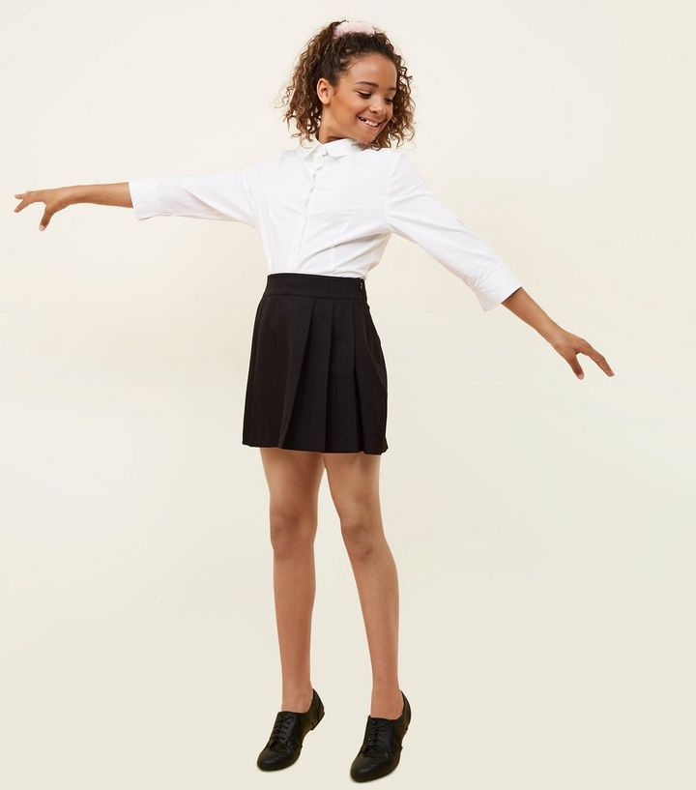

Trousers
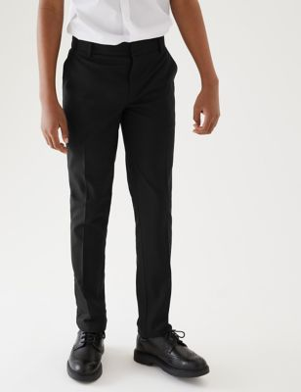
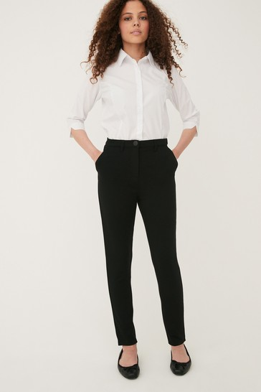
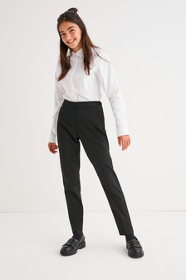
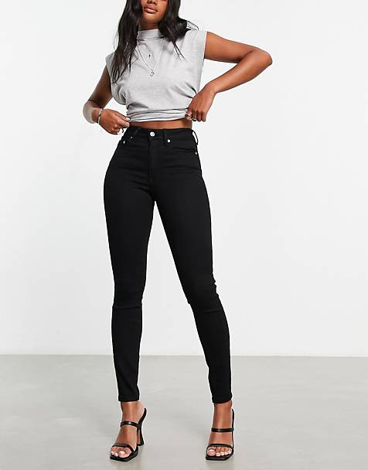
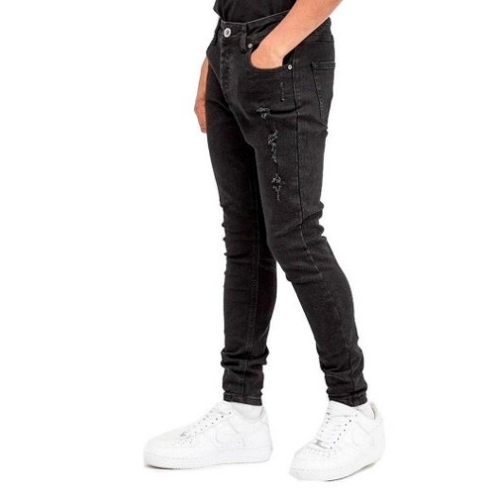
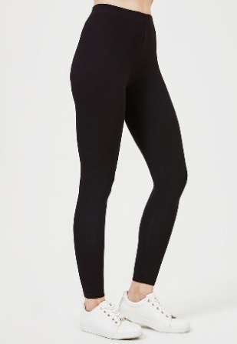

Footwear
All pupils should wear flat, black, closed toe shoes. They must not have white or coloured logos/branding. They must not have yellow/white or other coloured stitching. Trainers, knee-high boots, platform shoes and sandals of any sort are not permitted. See final page for further shoe guidance.

Personal appearance
- Hair colour and style must be natural and appropriate for school. No brightly coloured, dyed hair. Large hair accessories are also not permitted, e.g., bows, flowers
- Long hair must be tied back for practical subjects; PE, Science, D&T and Food technology
- Jewellery is not permitted with the exception of one pair of small stud earrings and a watch. Smart watches are not permitted unless contact controls have been disabled. Any item found to be causing a distraction or are inappropriately used during school hours will be confiscated
- Mobile phones, smart watches, air pods and other valuable items are not recommended and are brought into school at your own risk
- Due to health and safety requirements, students are not allowed to wear any jewellery for PE, this includes smart watches. If your child does wear earrings, they need to be able to remove them and recommend they bring a small box to put them in to keep safe. If they are not able to remove them, they will not be allowed to participate in the lesson
- Make up, nail varnish, false nails and fake tan are not permitted at any time
- If pupils choose to wear a hoodie to school it is only to be worn as a coat (for outdoor purposes) and therefore must be taken off in lessons, this includes PE/Competitive sport lessons as hoodies are a health and safety risk when taking part in any sport
Uniform stockist information
Walton Priory Middle School is mindful of the cost of uniform and has taken this into account when making decisions. Any uniform without our school logo can be purchased from any shop, such as supermarkets, as long as they meet our requirements.
There is uniform support available for those in receipt of Pupil Premium. This is considered on a case by case basis. Please contact the school office to discuss this further.
We will hold a sale of second-hand uniform in school on a half termly basis. Dates of sales will be announced via email and our social media channels.
Stockists
Schools In - Stone  Unit 11  Emerald way  Stone Business Park  Stone  ST15 0AL  01785 286700  www.schoolsinuniform.co.uk | Crested School Wear  35-36 Gaolgate street  Stafford  ST16 2NT  01785 748481  www.crestedschoolwear.co.uk
