September 2026
Dear Parent/Carer
We are pleased to inform you that in KS2 your child will be cooking for 14 weeks during the new academic year.
In response to parent feedback which indicated that parents would rather the school buy ingredients for cooking lessons than them being sent in from home, we will be continuing to ask for a contribution towards the cost of ingredients. I am sure you appreciate the value of this as it ensures all children have the correct ingredients for their lessons and there will be no forgotten items.
The charge for ingredients is £25.00; a payment item will be added to your ParentPay account. A 50% reduction in this contribution for children in receipt in pupil premium applies. The payment deadline is the 30th September 2026.
We can confirm that pupil’s food allergies will be catered for. We also ask that children bring a named, lidded container to take home the food they have made.
Please contact the school if you have any questions regarding paying for your child’s ingredients.
Thank you for your cooperation.
With regards
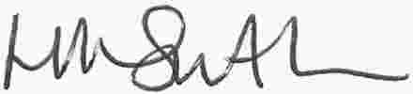
Miss Smith
Teacher of Food Technology

