
Walton Priory Middle School
15th October 2026

Dear Parents/Carers,
We are delighted to announce that our school choir will be taking part in Young Voices 2027 on Friday the 29th of January 2027 at the BP Pulse Live Birmingham
This is an incredible opportunity for our pupils to sing as part of one of the largest children’s choirs in the world. It promises to be a magical celebration of music, teamwork and joy, an experience your child will remember for years to come.

Key Information
- Date: Friday the 29th of January 2027
- Departure: 12:00pm (after an early school lunch)
- Return: Approx. 10:00pm (an ETA will be texted to parents on the evening)
- Meal: Pupils must bring a packed evening meal
- Cost: £20.00 each or £10.00 for Pupil Premium pupils
- Payment: Via ParentPay only
- Deadline: Sunday 8th November 2026 (payment + permission slip)
- Refunds: Payments are non-refundable
Consent Link
Young Voices - Friday 29th January 2027 – Fill out form

Extras
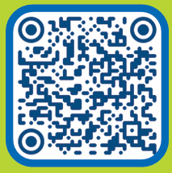
- Details for parent/carer ticket purchases can be found on the Young Voices Music Room website (QR code provided).
- To help you and your child prepare for this exciting experience, please activate your YV Parent Account by scanning the QR code. Once you’ve created your account, simply add your child to unlock the YV Music Room and start learning the YV 2027 songs – all completely free
Thank you for your support, we can’t wait to share this exciting event with our choir!
Kind regards,
Mrs Braddock

